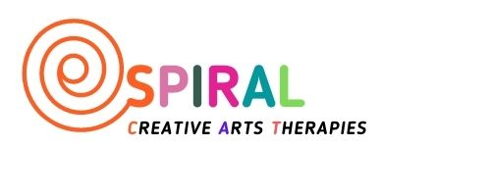
Spiral -Creative Arts Therapies is a Scottish Charitable Incorporated Organisation, started in 2020. We aim to improve the emotional health and wellbeing of children and young people.
Spiral has an experienced staff team who are no strangers in delivering arts therapies programmes for children and young people in our local communities.
We are looking for a Company Administrator to join our team and support our projects.

SPIRAL-CREATIVE ARTS THERAPIES
JOB DESCRIPTION

POST: Company Administrator.
(0.2 FTE, Fixed term 12 month contract, renewable depending on funding)
REPORTS TO: Director
PRINCIPLE PURPOSE: To provide effective and efficient administrative support for Spiral-Creative Arts Therapies,
ORGANISATIONAL POSITION: See below

PRINCIPLE DUTIES AND RESPONSIBILITIES
Company administration
- Responsible for the efficient running of the Spiral Creative Arts Therapies office
- First point of contact for all enquiries: email, telephone and in person
- Maintaining office filing systems and office supplies
- Managing Mail and postage
- Maintain contact lists and database
- Assist with recruitment process including PVG membership
- Co-ordinate TOIL sheets, holiday log and request forms
- Co-ordinate, attend, prepare papers, take and circulate the minutes for company Board meetings and AGM
- Co-ordinate and minute team meetings
- Assist with production of reports to funders
- To assist with special events
- Work with Finance officer to ensure annual reports and submissions to OSCR are completed before required deadlines
- To support company fundraising strategy and projects.

PERSON SPECIFICATION
Essential criteria
- Experience in working with in an office environment.
- Excellent computer skills (Microsoft Office - Word, Excel, Outlook, Powerpoint)
- Strong organisational skills
- Experience and interest in communications including writing content, maintaining websites and social media platforms
- Good communicator (both written and verbal) and highly developed interpersonal skills with people at all levels, both internally and externally
- Good time management and ability to prioritise
- Excellent attention to detail
- Strong self-motivation and ability to manage own time effectively with minimum supervision
- A team player and confident autonomous worker.
- Ability to work co-operatively with internal and external colleagues.

Desirable
- An understanding of therapeutic arts

BUDGET AND TIMETABLE:
Annual salary: £21,000 (Pro rata - 0.2FTE)
Contract: 12 month Fixed term contract, renewable depending on funding
Hours: 7.5 hours per week (1 day - working day is 7.5hrs). Some occasional evening and weekend work for which time off in lieu will be given
Location: A mix of blended working to include
Spiral -Creative Art Therapies office in Glasgow
Notice: 4 weeks’ notice is required and will be given
Holidays: 30 working-days annual leave (pro rata). 9 statutory public holidays (pro rata)
Sick leave: Statutory sickness benefits apply

